**SQL Assignment – 3**

--> Creating Database Called **WorkDB**

CREATE DATABASE WorkDB

USE WorkDB



-->Creating table named **Department**

**CREATE** TABLE Department

(

Dept_id INT PRIMARY KEY NOT NULL,

Dept_name NVARCHAR(50)

)

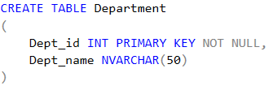

-->Creating table named **Employee**

**CREATE** TABLE Employee

(

Emp_id INT PRIMARY KEY NOT NULL,

Dept_id INT NOT NULL,

Mngr_id INT,

Emp_name NVARCHAR(50) NOT NULL,

Salary Money,

FOREIGN KEY(Dept_id) REFERENCES Department(Dept_id)

)

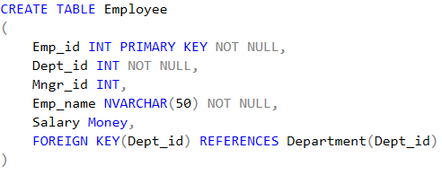

--> Inserting data into Created Table

INSERT INTO Department values (1001, 'Finance')

INSERT INTO Department values (2001, 'Audit')

INSERT INTO Department values (3001, 'Marketing')

INSERT INTO Department values (4001, 'Production')

INSERT INTO Employee values (501,1001,NULL,'Kavan',60000)

INSERT INTO Employee values (502,3001,501,'Naman',27500)

INSERT INTO Employee values (503,1001,501,'Sparsh',25500)

INSERT INTO Employee values (504,2001,501,'John',29570)

INSERT INTO Employee values (505,2001,504,'Arsh',31000)

INSERT INTO Employee values (506,2001,504,'Vedant',31000)

INSERT INTO Employee values (507,2001,506,'Hetvi',9000)

INSERT INTO Employee values (508,3001,502,'Aarchi',17000)

INSERT INTO Employee values (509,3001,502,'Williams',13500)

INSERT INTO Employee values (510,3001,502,'Maya',13500)

INSERT INTO Employee values (511,3001,502,'Tirth',16000)

INSERT INTO Employee values (512,2001,505,'Adity',12000)

INSERT INTO Employee values (513,3001,502,'Jay',10500)

INSERT INTO Employee values (514,4001,515,'Mrugesh',14000)

INSERT INTO Employee values (515,4001,NULL,'Steve',25000)

--> Viewing Inserted data:

SELECT * FROM Department

SELECT * FROM Employee

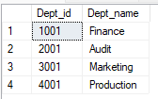

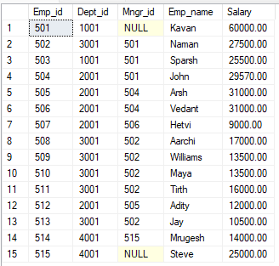

Query 1: write a SQL query to find Employees who have the biggest salary in their Department

SELECT DISTINCT E.Emp_id, E.Emp_name, D.Dept_id, D.Dept_name, E.Salary

FROM Employee E

Inner Join Department D

ON D.Dept_id = E.Dept_id,

(SELECT K.Dept_id,MAX(Salary) AS 'MAXSAL'

FROM Employee K

Group By Dept_id) Y

WHERE E.Dept_id=Y.Dept_id AND E.Salary = Y.MAXSAL

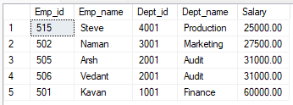

Query 2 : write a SQL query to find Departments that have less than 3 people in it.

SELECT D.Dept_id, D.Dept_Name, Y.Total 'Total Employees' FROM

(SELECT E.Dept_id,

COUNT(E.Emp_id) AS Total

FROM Employee E Group By E.Dept_id Having COUNT(E.Emp_id) < 3) Y

inner Join Department D

ON D.Dept_id = Y.Dept_id

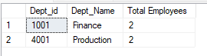

Query 3 : write a SQL query to find All Department along with the number of people there

SELECT D.Dept_id, D.Dept_Name, Y.Total 'Total Employees' FROM

(SELECT E.Dept_id,

COUNT(E.Emp_id) AS Total

FROM Employee E group by E.Dept_id) Y

inner Join Department D

ON D.Dept_id = Y.Dept_id

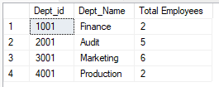

Query 4 : write a SQL query to find All Department along with the total salary there

SELECT D.Dept_id, D.Dept_Name, Y.Salary 'Total Salary' FROM

(SELECT E.Dept_id,

SUM(Salary) AS 'Salary'

FROM Employee E group by E.Dept_id) Y

inner Join Department D

ON D.Dept_id = Y.Dept_id

